A picture containing clipart

Description generated with very high confidence

Azure 103 Module 4

Hands On - 8

Azure Certification Training

[**support@intellipaat.com**](mailto:support@intellipaat.com)

**+91-7022374614**

**US: 1-800-216-8930(Toll Free)**

**Azure 103 Module 4 , Hands On – 8**

**Create NIC**

**Step 1:** Search Network Interfaces and Click on it.

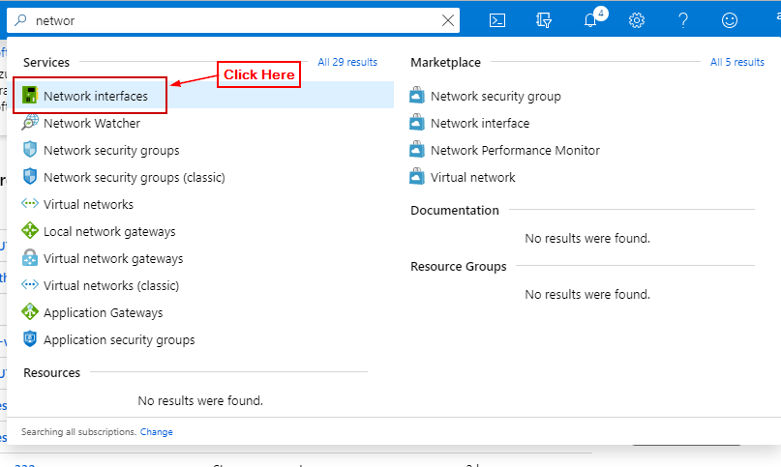

**Step 2:** Click on + Add.

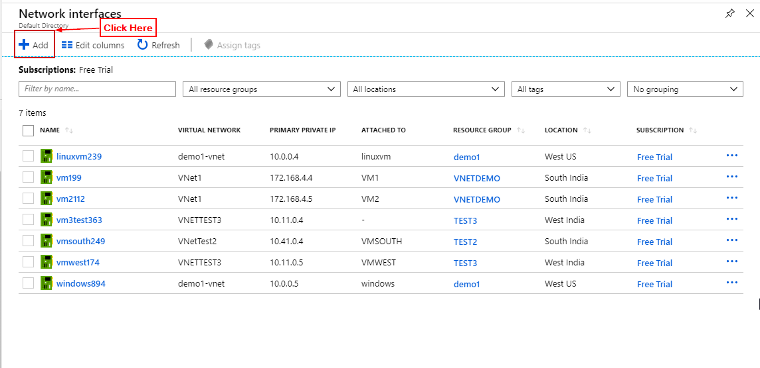

**Step 3:** Enter details and Click Create.

